Health Potions:

* Aloe (mostly for external use, helps heal wounds)
* Anise
* Chamomile
* Comfley

“Love” Potion:

* Cinnamon
* Roses
* Cunin
* Salvia

“Death” potion:

* Basil (as some believed if consumed, it would cause insanity)
* Buckthorn
* Oleander
* Water Hemlock

“numbing” potion

* Mint
* Aloe
* Chamomile
* Basil

Booster Potion:

* Rosemary
* Cinnamon
* Mint
* Salvia

List of herbs:

1. Aloe
2. Anise
3. Basil
4. Buckthorn
5. Chamomile
6. Cinnamon
7. Comfley
8. Cunin
9. Mint
10. Oleander
11. Roses
12. Rosemary
13. Salvia
14. Water Hemlock

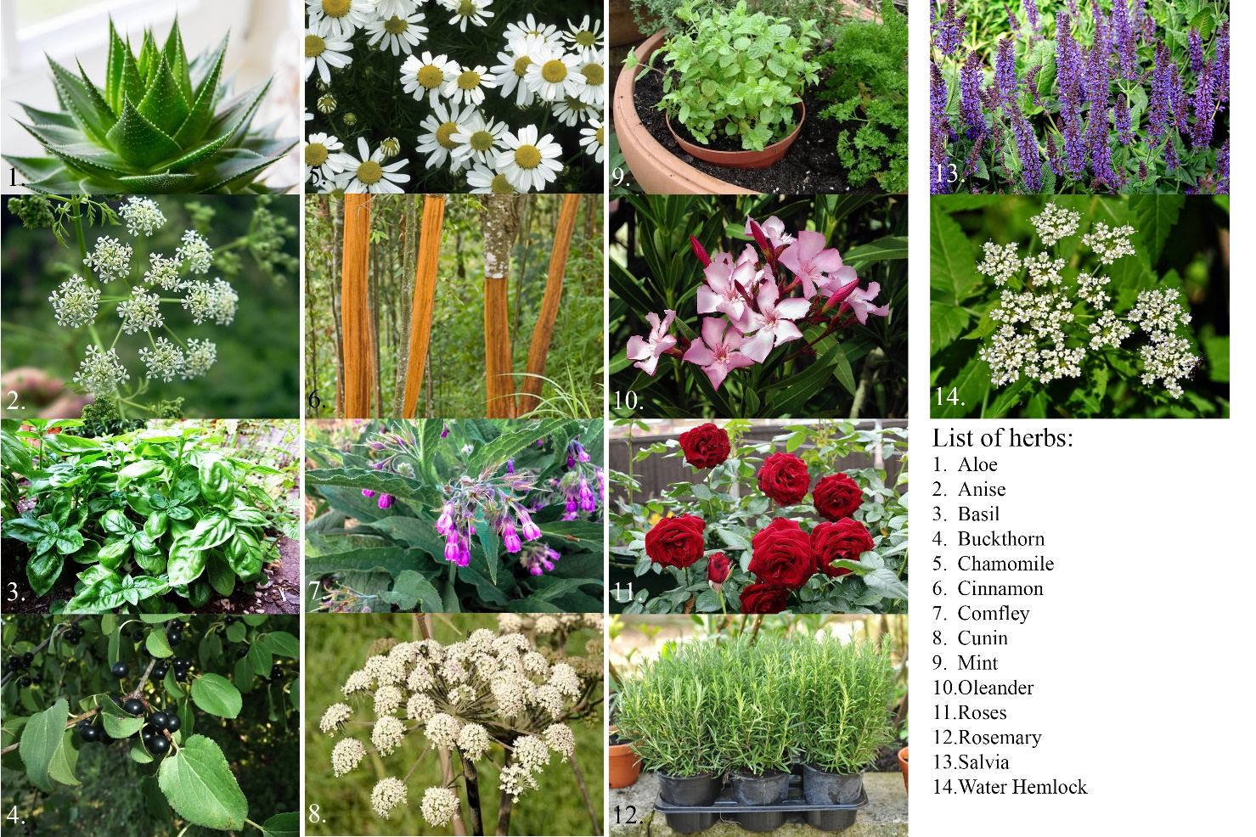

Useful links:

https://www.britannica.com/list/7-of-the-worlds-deadliest-plants